Communicate

2023-02-05

## R Markdown

This is an R Markdown document. Markdown is a simple formatting syntax for authoring HTML, PDF, and MS Word documents. For more details on using R Markdown see <http://rmarkdown.rstudio.com>.

When you click the **Knit** button a document will be generated that includes both content as well as the output of any embedded R code chunks within the document. You can embed an R code chunk like this:

library(tidyverse)

## ── Attaching packages ─────────────────────────────────────── tidyverse 1.3.2 ──  
## ✔ ggplot2 3.4.0 ✔ purrr 0.3.5   
## ✔ tibble 3.1.8 ✔ dplyr 1.0.10  
## ✔ tidyr 1.2.1 ✔ stringr 1.5.0   
## ✔ readr 2.1.3 ✔ forcats 0.5.2   
## ── Conflicts ────────────────────────────────────────── tidyverse_conflicts() ──  
## ✖ dplyr::filter() masks stats::filter()  
## ✖ dplyr::lag() masks stats::lag()

cars %>%  
 ggplot(aes(speed, dist))+geom_point()

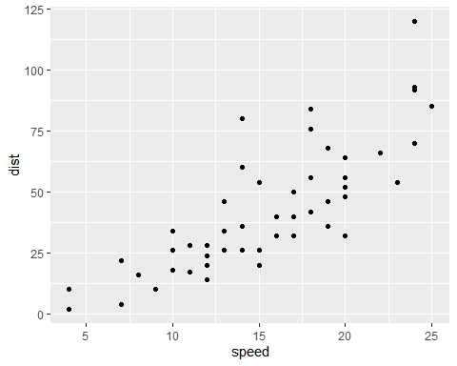

## Including Plots

You can also embed plots, for example:

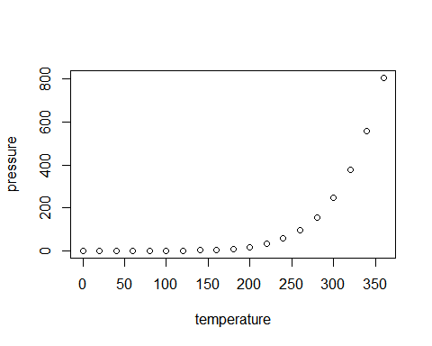

Note that the echo = FALSE parameter was added to the code chunk to prevent printing of the R code that generated the plot.